https://in.mathworks.com/help/images/deep-learning.html

- Contact Us
- How to Buy
- Log In

- Products
- Solutions
- Academia
- Support
- Community
- Events

Documentation

- Trial Software
- Product Updates
- Translate This Page
- Documentation Home
- Image Processing Toolbox
- Getting Started with Image Processing Toolbox
- Import, Export, and Conversion
- Display and Exploration
- Geometric Transformation and Image Registration
- Image Filtering and Enhancement
- Image Segmentation and Analysis
- Deep Learning for Image Processing
- 3-D Volumetric Image Processing
- Code Generation
- GPU Computing
- Examples
- Functions
- Classes
- Apps
- Release Notes
- PDF Documentation

Deep Learning for Image Processing
Remove image noise using convolutional neural networks (requires Neural Network Toolbox™)
Deep learning uses neural networks to learn useful representations of features directly from data. For example, you can use a pretrained neural network to identify and remove Gaussian noise from images.
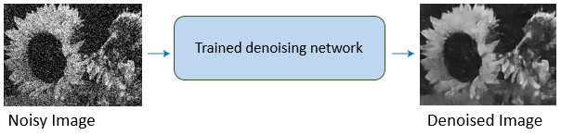

Functions
denoiseImage | Denoise image using deep neural network
denoisingNetwork | Get image denoising network
denoisingImageSource | Denoising image source
dnCNNLayers | Get denoising convolutional neural network layers

Topics

Remove Image Noise Using Neural Networks
Train and Apply Denoising Neural Networks
Use a pretrained neural network to remove Gaussian noise from a grayscale image, or train your own network using predefined layers.
Remove Noise from Color Image Using Pretrained Neural Network

This example shows how to remove Gaussian noise from an RGB image, by using a pretrained denoising neural network.

Deep Learning Applications in MATLAB
Deep Learning in MATLAB (Neural Network Toolbox)
Discover deep learning capabilities in MATLAB® using convolutional neural networks for classification and regression, including pretrained networks and transfer learning, and training on GPUs, CPUs, clusters, and clouds.
Pretrained Convolutional Neural Networks (Neural Network Toolbox)
Learn how to download and use pretrained convolutional neural networks for classification, transfer learning and feature extraction.
Transfer Learning Using Convolutional Neural Networks (Neural Network Toolbox)
This example shows how to classify new image data by fine-tuning an existing, pretrained convolutional neural network.
Semantic Segmentation Using Deep Learning (Computer Vision System Toolbox)
This example shows how to train a semantic segmentation network using deep learning.
Object Detection Using Deep Learning (Computer Vision System Toolbox)
This example shows how to train an object detector using deep learning and R-CNN (Regions with Convolutional Neural Networks).
Was this topic helpful?

Image Processing Toolbox Documentation
- Examples
- Functions and Other Reference
- Release Notes
- PDF Documentation

Other Documentation
- MATLAB
- Computer Vision System Toolbox
- Signal Processing Toolbox
- Statistics and Machine Learning Toolbox
- Symbolic Math Toolbox
- Documentation Home

Support
- MATLAB Answers
- Installation Help
- Bug Reports
- Product Requirements
- Software Downloads
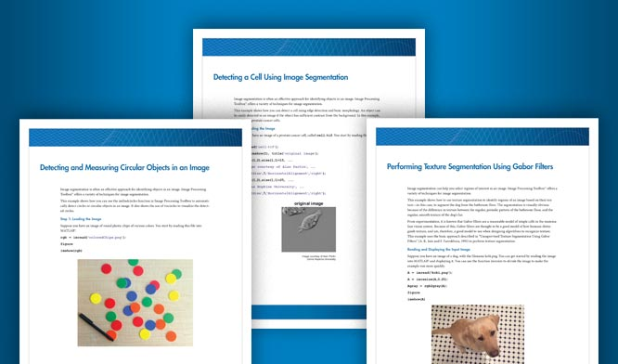

Image Segmentation and Thresholding Code Examples
Download now

Explore Products
- MATLAB
- Simulink
- Student Software
- Hardware Support
- File Exchange

Try or Buy
- Downloads
- Trial Software
- Contact Sales
- Pricing and Licensing

Learn to Use
- Documentation
- Tutorials
- Examples
- Videos and Webinars
- Training

Get Support
- Installation Help
- Answers
- Consulting
- Application Status
- License Center

About MathWorks
- Careers
- Newsroom
- Social Mission
- About MathWorks

MathWorks
Accelerating the pace of engineering and science
MathWorks is the leading developer of mathematical computing software for engineers and scientists.
Discover...
- India
- Patents
- Trademarks
- Privacy Policy
- Preventing Piracy
© 1994-2017 The MathWorks, Inc.
- 
Join the conversation

